Live Detection Basic User’s Guide

## IriSmartEye 2000 Liveness Installation

The IriSmartEye 2000 liveness is a software demonstrating how IriShieldTM-USB camera liveness detection. Please follow the instructions below to install the software on Windows.

**Note:** The IriSmartEye 2000 Liveness software version on the screen may differ from yours. The software version is subject to change without notice.

1. In the “IriSmartEye2000_3.6.9.2_windows_x64_India” folder in the software package, double click the “**setup.exe**” file.

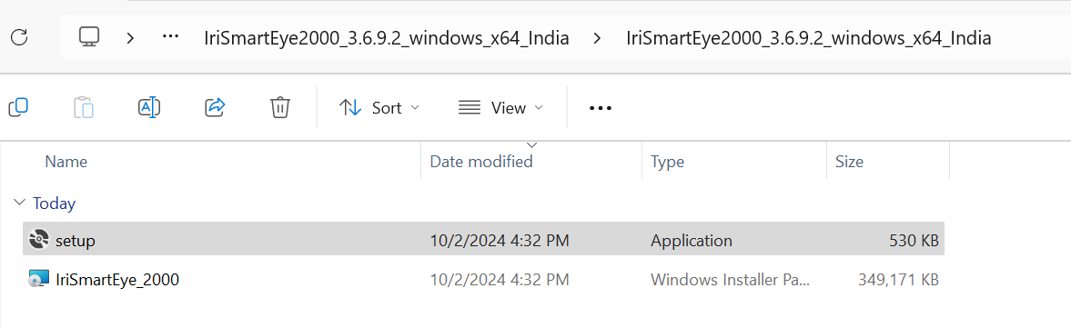

1. Read the license agreement terms carefully, select “**I Agree**,” then click “**Next**”.

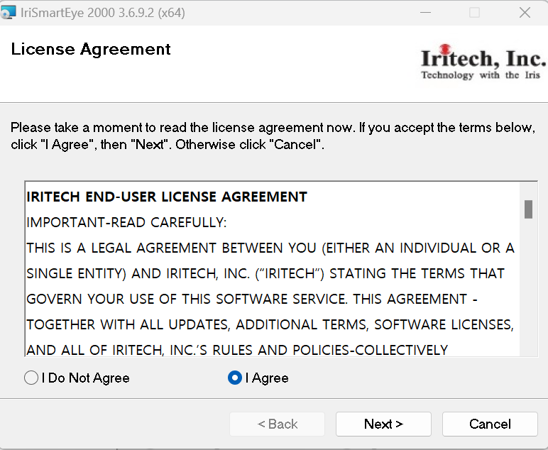

1. The Setup Wizard will appear. Click “**Next**” for setup.

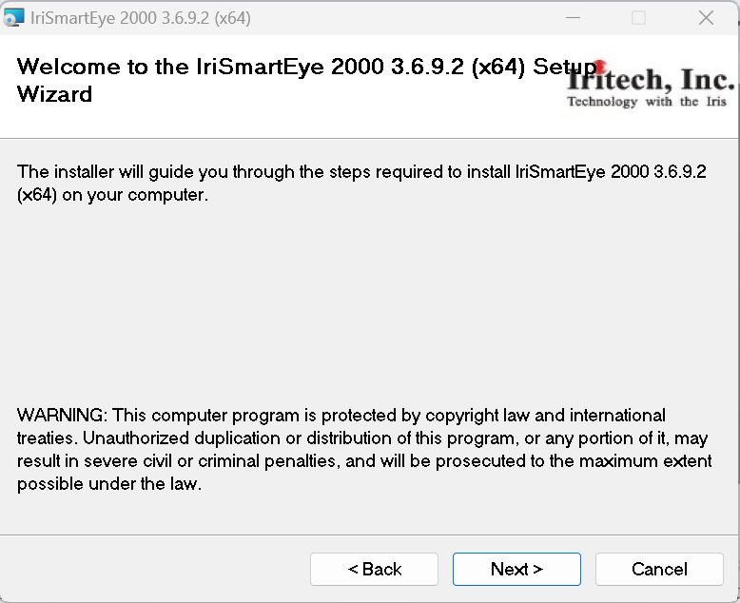

1. If you want to install this program in a different folder, click “**Browse**” and specify the desired folder. Click “**Next**” to continue with the default or selected destination folder.

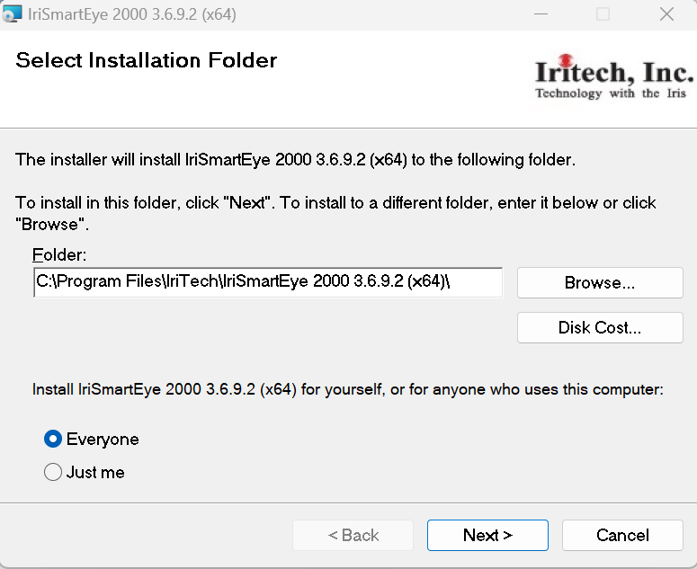

1. Select option “**Yes, Create shortcut on the Desktop**”, then click “**Next**” to continue.

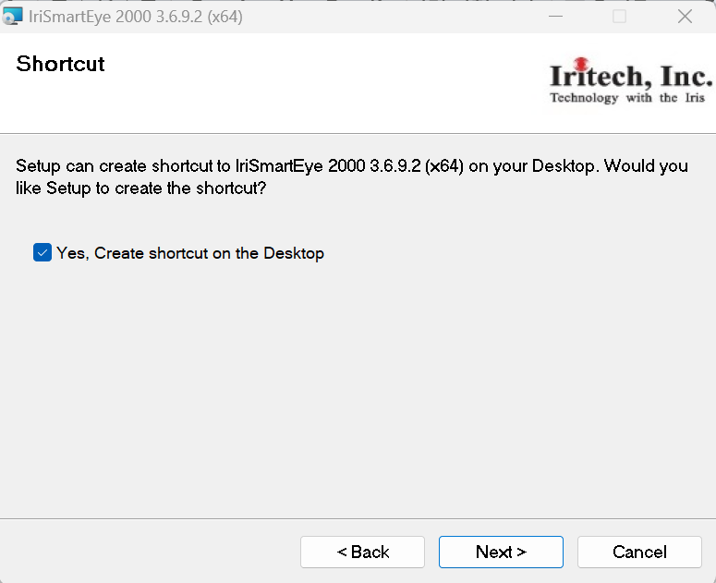

1. If you click “**Next**” on the confirmation window, the IriSmartEye 2000 application will start to be installed.  
   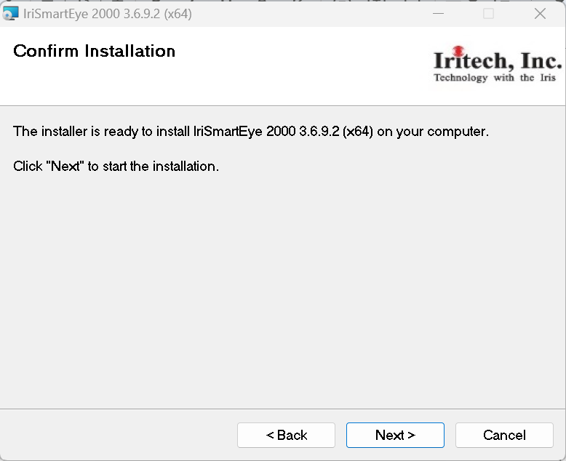
2. Wait for the installation process to be complete, then click “**Close**.”  
   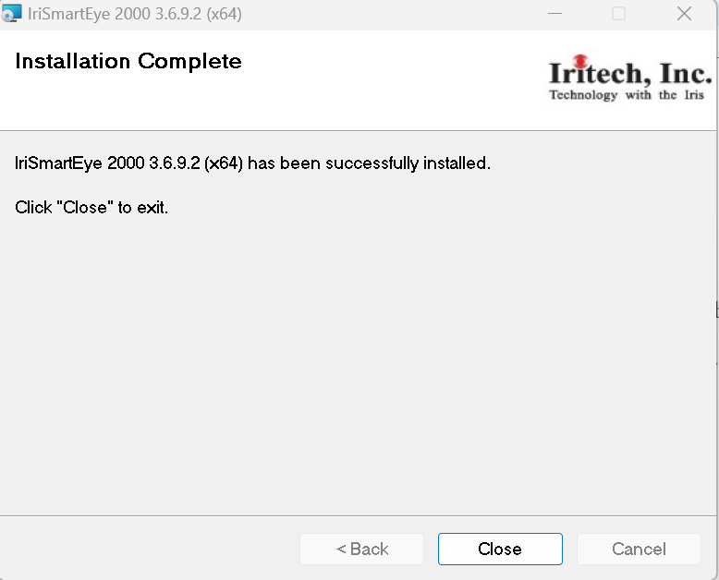
3. You can verify whether the program is properly installed by examining the selected destination folder on your computer.

(“C:\Program Files\Iritech\IriSmartEye 2000 3.6.9.2 (x64)” - The folder name may be different for each version.)  
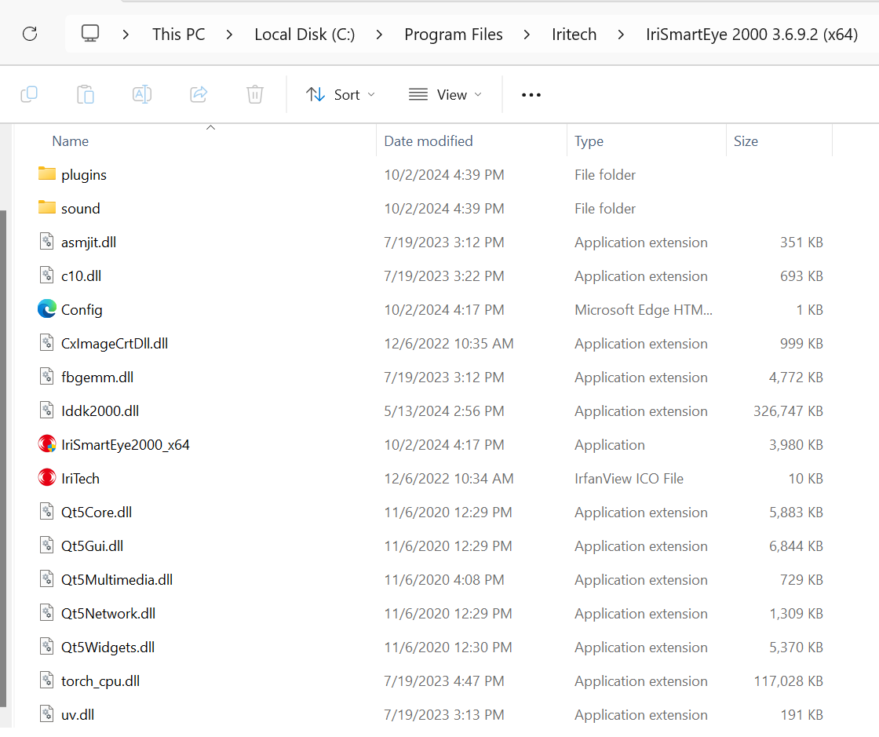

## IriSmartEye 2000 Liveness Software

For Windows 10 OS’s, IriSmartEye 2000 application can be started from the “Start menu” and search “IriSmartEye2000_x64”.

## Configuration

This section must be done before any further functionalities of the program can get ready to work.

1. Select the “**Setting**” tab.  
   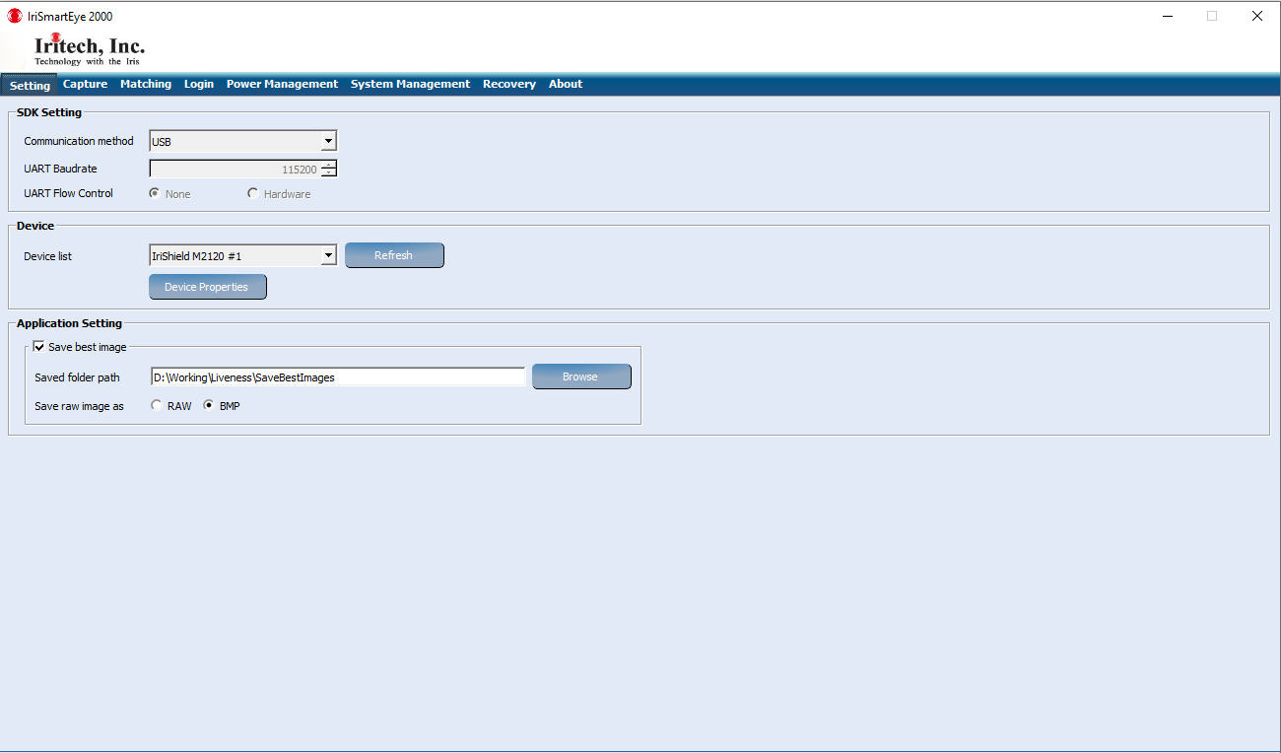
2. Click “**Refresh**” to refresh list of IriShieldTM-USB device in case of USB communication is selected
3. To view more information about the selected device, click ”**Device Properties**”.  
   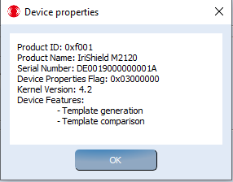

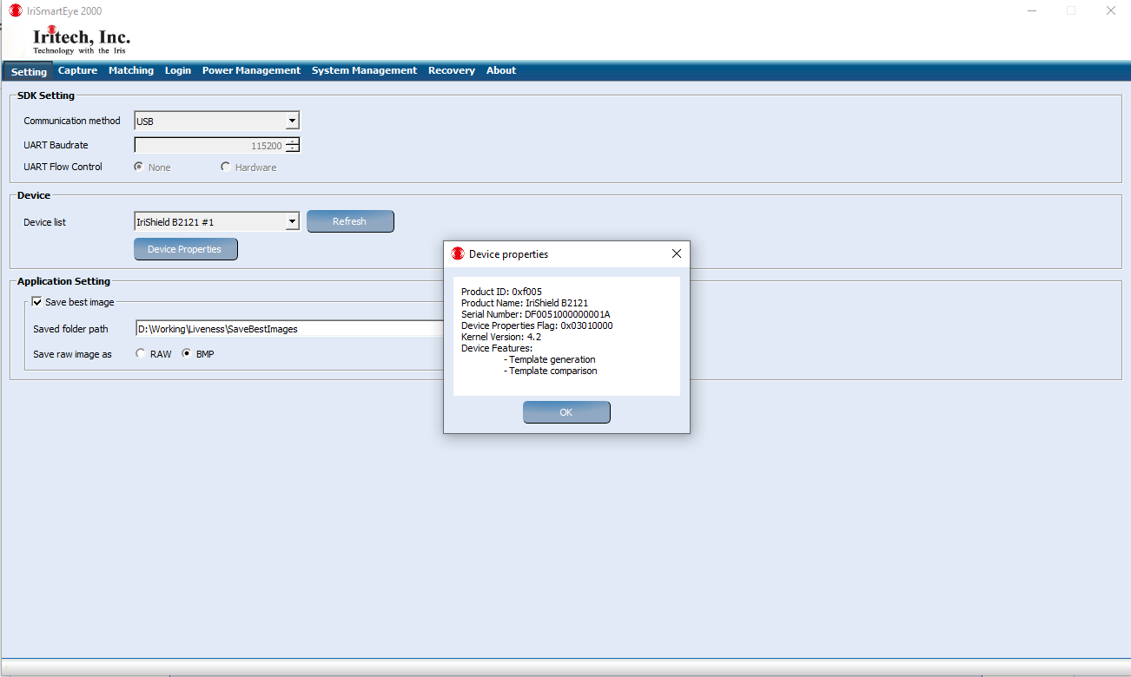

## Iris Image Capturing using Mono IriShield

* Select the “**Capture**” tab, the screen will be shown as in below. Default app uncheck option: Liveness  
     
  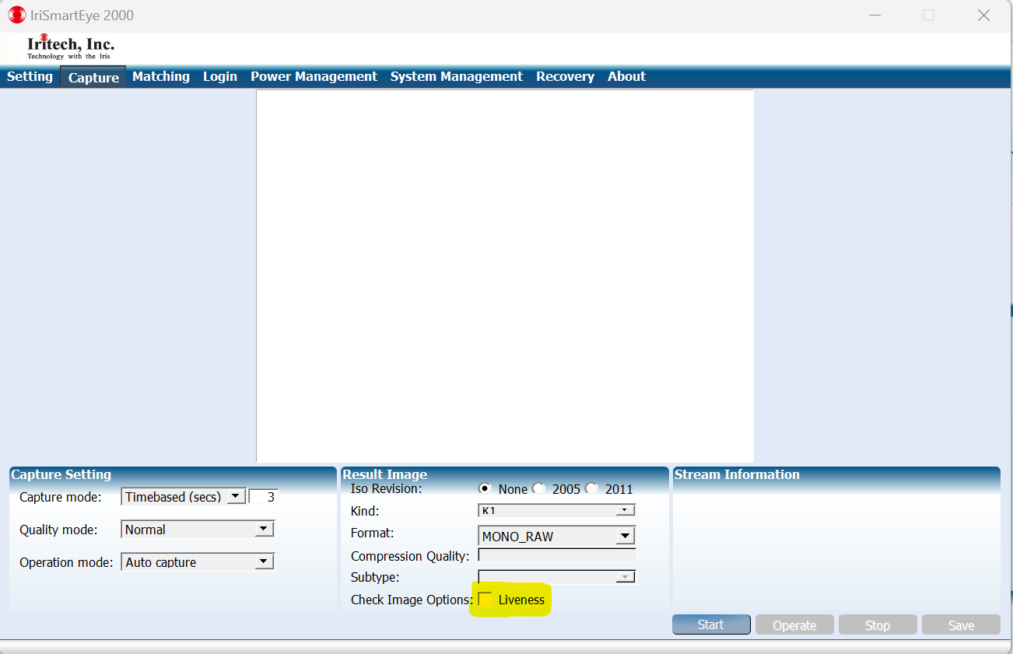

### Auto Capture check liveness option

1. Select the “**Capture**” tab on the application.
2. Select “**Auto capture**” in “Operation mode”.
3. Check on checkbox “**Liveness**” in “**Check Image Options**”
4. Click the “Start” button to start capturing irises.
5. Keep your eyes wide open, gaze straight ahead, and align your eye so that it appears centered in the camera mirror.(Closing the other eye may help with the alignment.)
6. Approach the camera slowly from a distance of about 5 cm (2 inches) away from the front of the camera. The IriSmartEye 2000 Liveness software will prompt 'Keep moving' when it detects the first in-focus iris image. (To hear the message, the computer must have a sound card and a speaker turned on.)
7. After hearing the message 'Keep moving,' it is best to continue moving steadily towards the camera to meet the focus distances until the system emits a 'shutter click' sound. This indicates that it has selected a qualified iris image and completed the capturing process.
8. If a non-qualified iris image is captured, an error message stating 'No frame was qualified. Please try again.' will appear on the computer..

Note: If power is disconnected from the camera, such as during the closing of a laptop, it will take a few seconds after power is reestablished for the camera to operate normally.

* + 1. **Auto Capture Mode check liveness option with REAL EYES**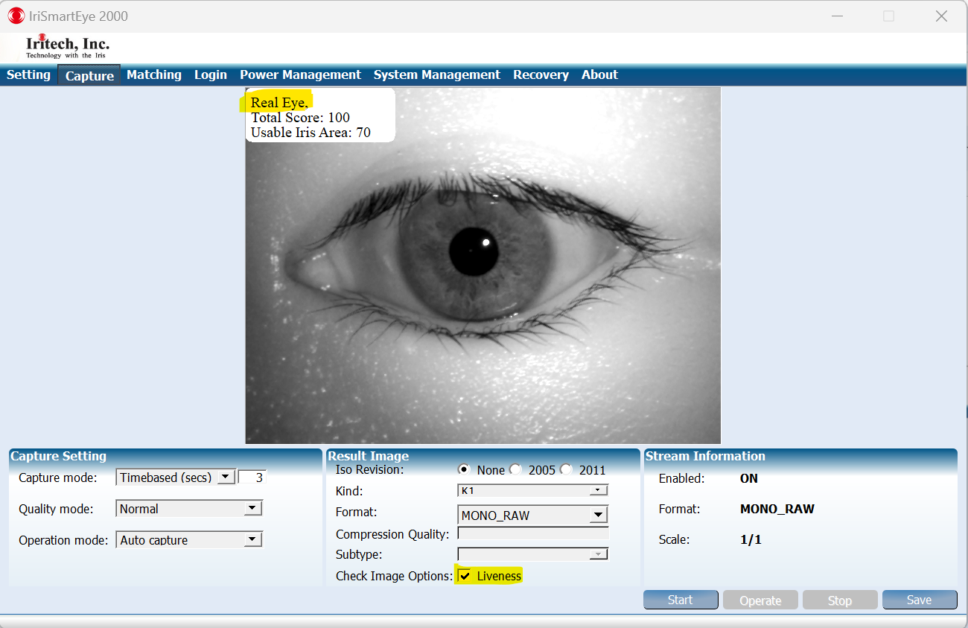  
       **Liveness Status: Real Eye**
    2. **Auto Capture Mode check liveness option with FAKE EYES (Printed Images Sample 1)  
       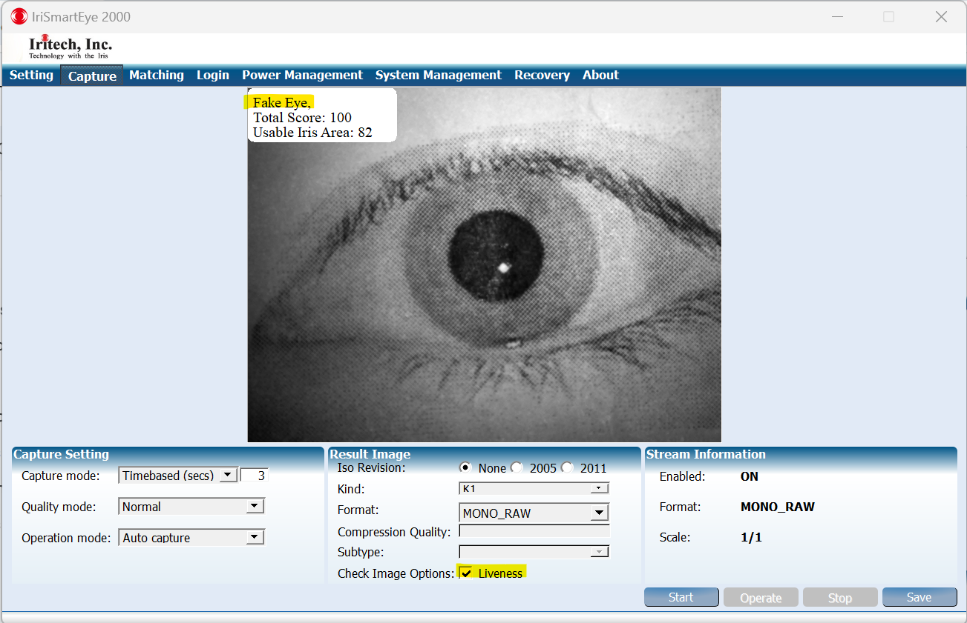  
         
       Liveness Status: Fake Eye**
    3. **Auto Capture Mode check liveness option with FAKE EYES (Printed Images Sample2)  
       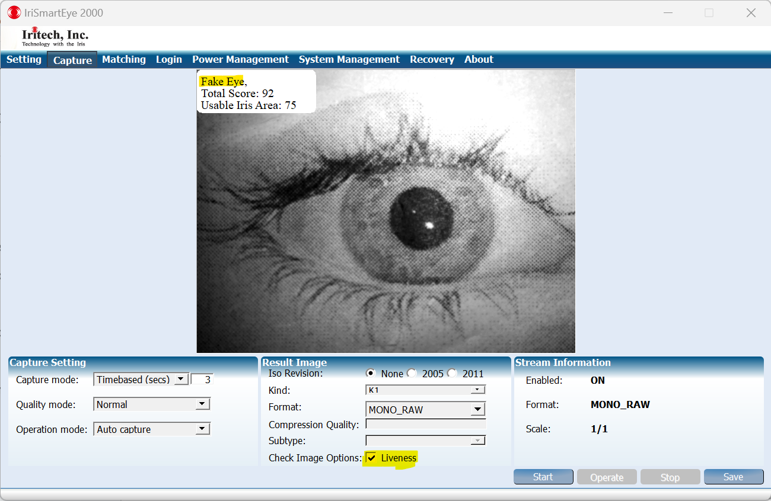  
       Liveness Status: Fake Eye**
    4. **Auto Capture Mode check liveness option with FAKE EYES (Printed Images Sample3)**  
        **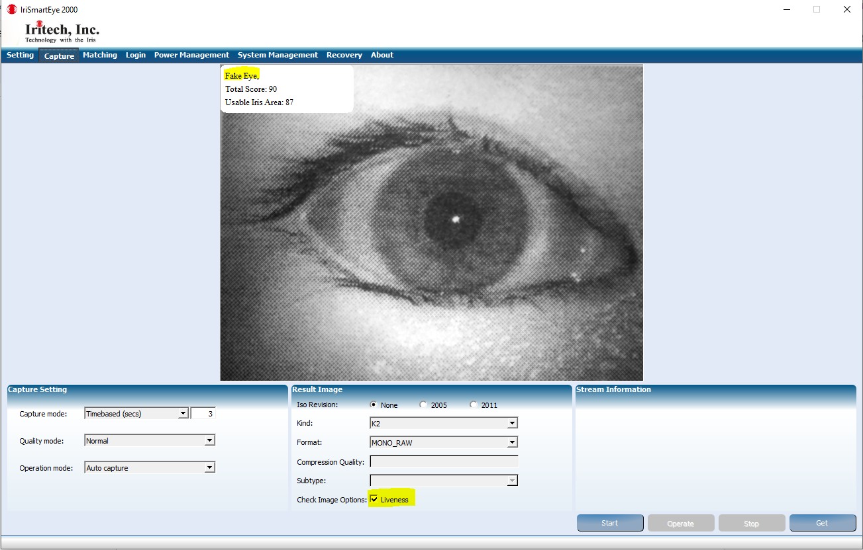  
       Liveness Status: Fake Eye**
    5. **Auto Capture Mode check liveness option with FAKE EYES (Artificial Eyes Sample 1)  
       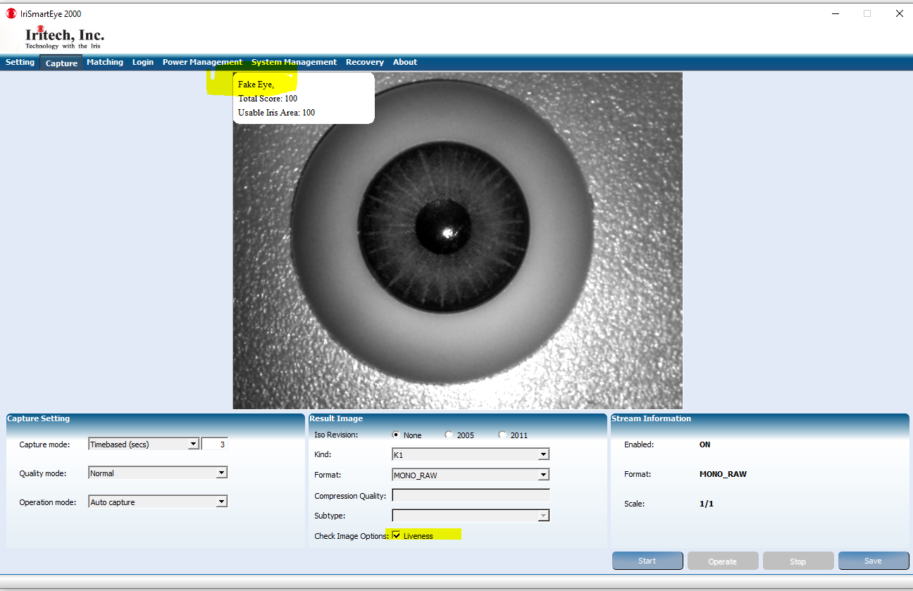  
       Liveness Status: Fake Eye**
    6. **Auto Capture Mode check liveness option with FAKE EYES (Artificial Eyes Sample 2)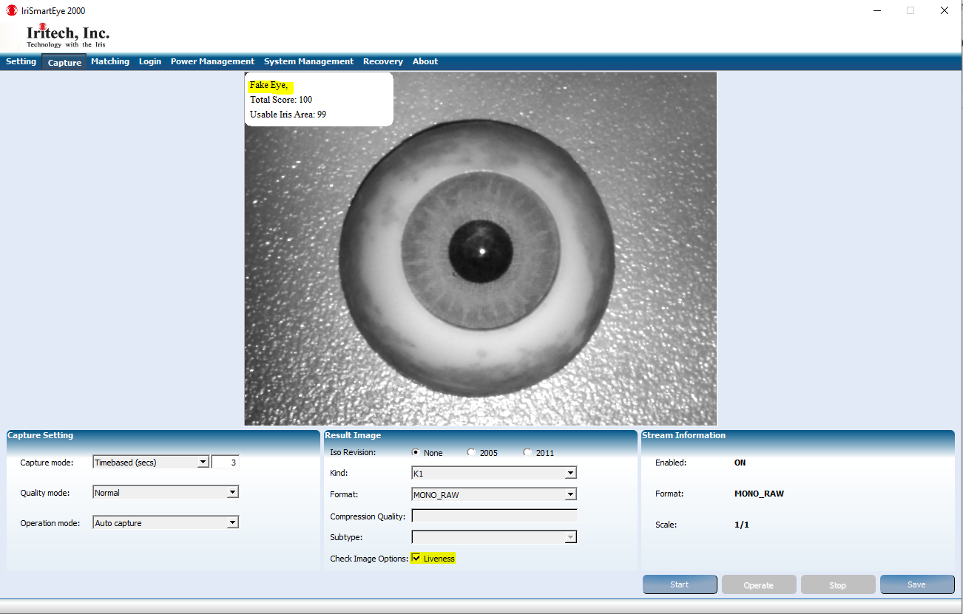 Liveness Status: Fake Eye**
    7. **Auto Capture Mode check liveness option with FAKE EYES (Artificial Eyes Sample 3)**  
       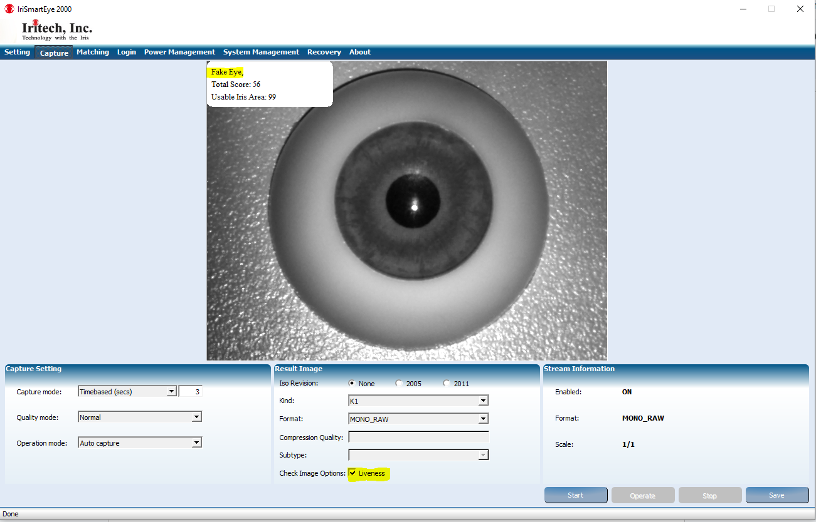  
       **Liveness Status: Fake Eye**

## Iris Image Capturing using Bino IriShield

Select the “**Capture**” tab, the screen will be shown as in below. Default app uncheck option: Liveness  
   
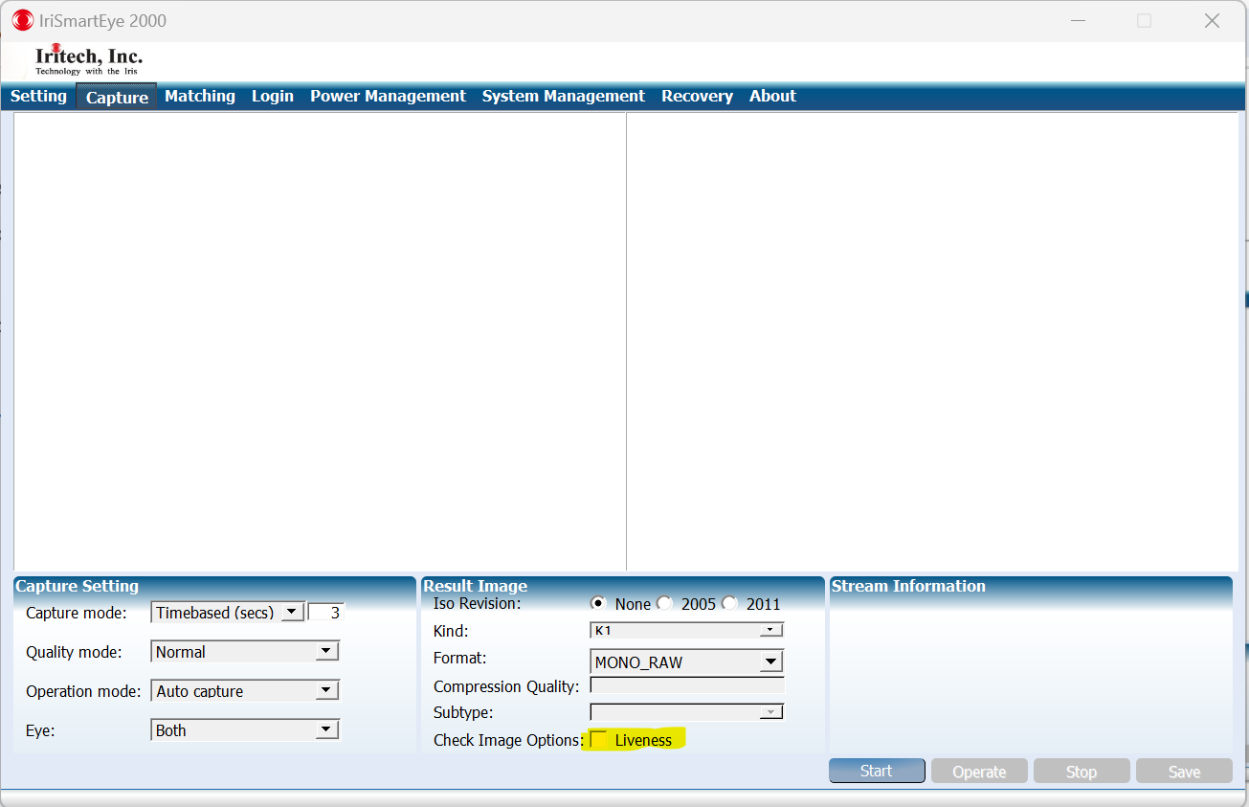

### Auto Capture check liveness option

1. Select the “**Capture**” tab on the IriSmartEye 2000 application.
2. Select “**Auto capture**” in “Operation mode”.
3. Select “**Both**” in “Eye”.
4. Check on checkbox “**Liveness**” in “**Check Image Options**”
5. Click the “**Start**” button to start capturing irises.
6. Keep your eyes wide open, gaze straight ahead, and align your eyes so that it appears centered in the camera mirror.
7. When the application detects the first in-focus iris image, it will prompt 'Keep moving. (Note: To hear the message, the computer must have a sound card and a speaker turned on.)
8. After hearing the message 'Keep moving,' it is best to continue moving steadily towards the camera to meet the focus distances until the system emits a 'shutter click' sound. This indicates that it has selected a qualified iris image and completed the capturing process.
9. If a non-qualified iris image is captured, an error message stating 'No frame was qualified. Please try again.' will appear on the computer.

Note: If power is disconnected from the camera, such as during the closing of a laptop, it will take a few seconds after power is reestablished for the camera to operate normally..

* + 1. **Auto Capture Mode check liveness option with Real Eye**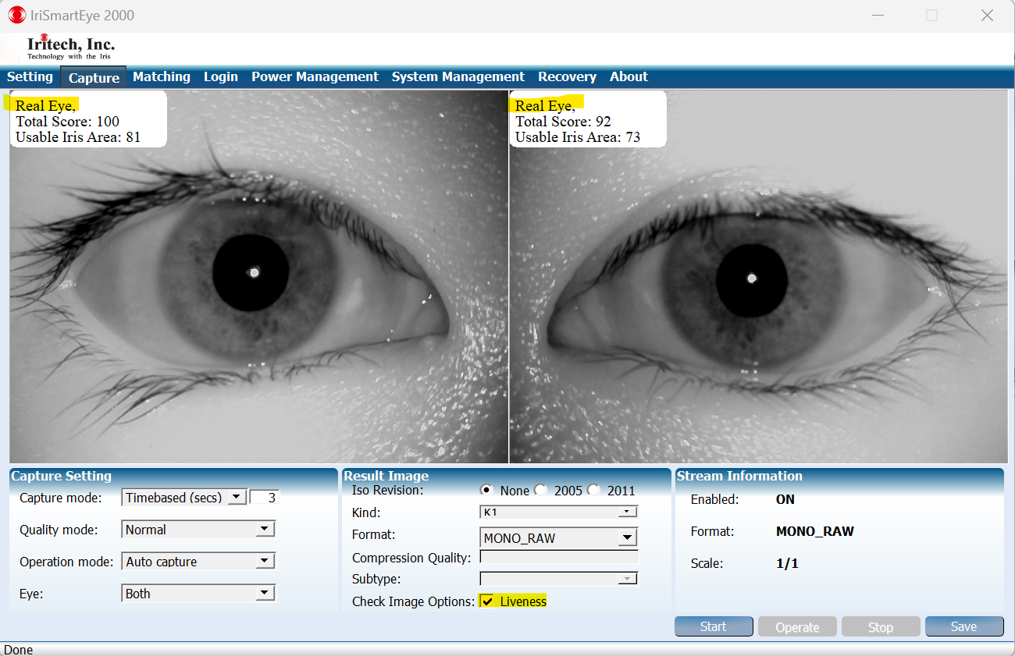  
       **Liveness Status: Real Eye**
    2. **Auto Capture Mode check liveness option with Fake Eye (Printed Images Sample)**  
       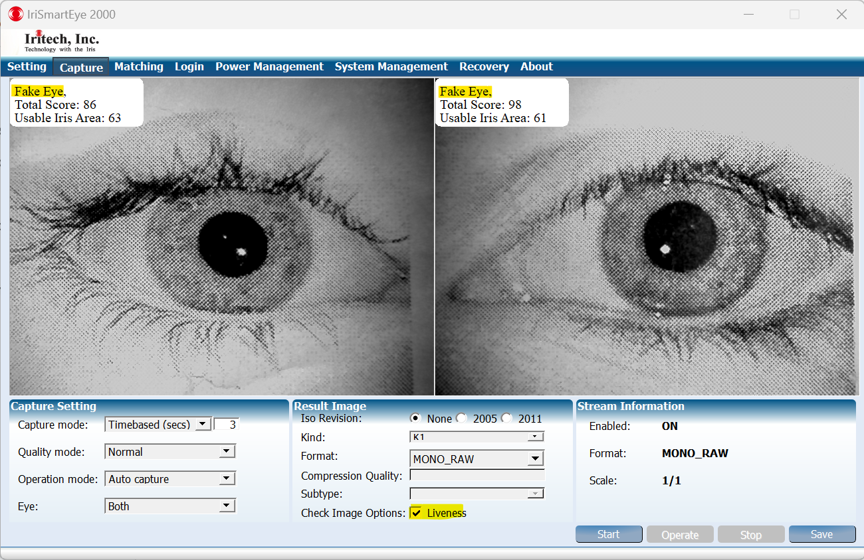

**Liveness Status: Fake Eye**

* + 1. **Auto Capture Mode check liveness option with Fake Eye (Artificial Eyes Sample )  
       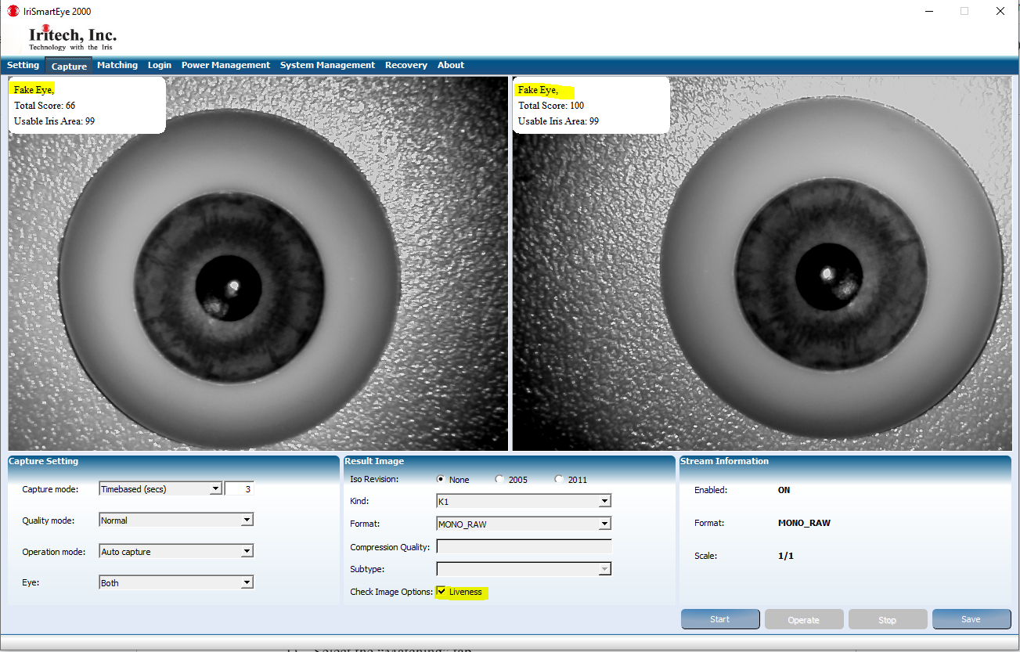  
       Liveness Status: Fake Eye**

## Matching check liveness option

1. Select the “Matching” tab.
2. This section includes four functionalities: Enroll, Unenroll, Verify, and Identify.
   * 1. **Verify**
3. After getting a captured iris image, select an enrollment ID against the image that needs to be verified.
4. Click the “Verify” button. If the image belongs to the person with that ID (i.e., positive match), the resulting message is shown as in below.

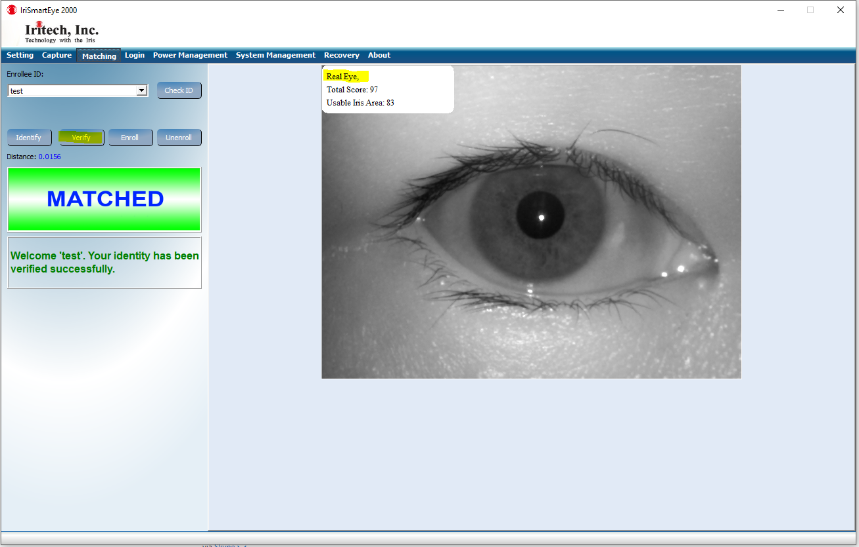

1. If the captured image is a fake image so it is not matched, the negative message is shown below.

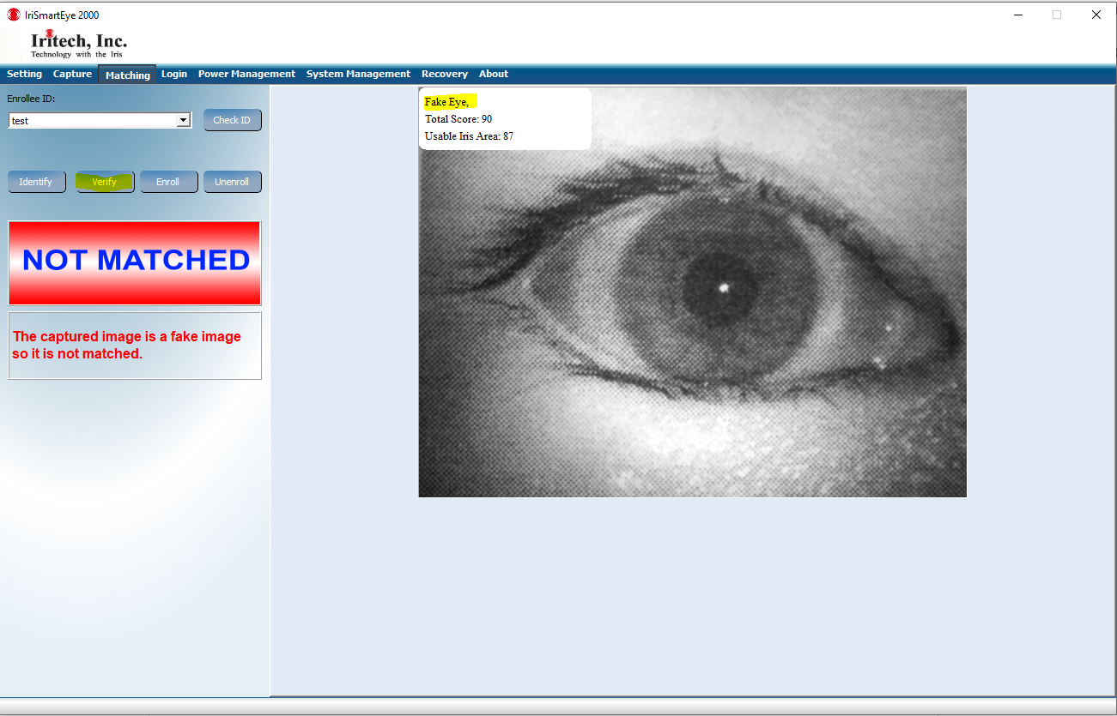

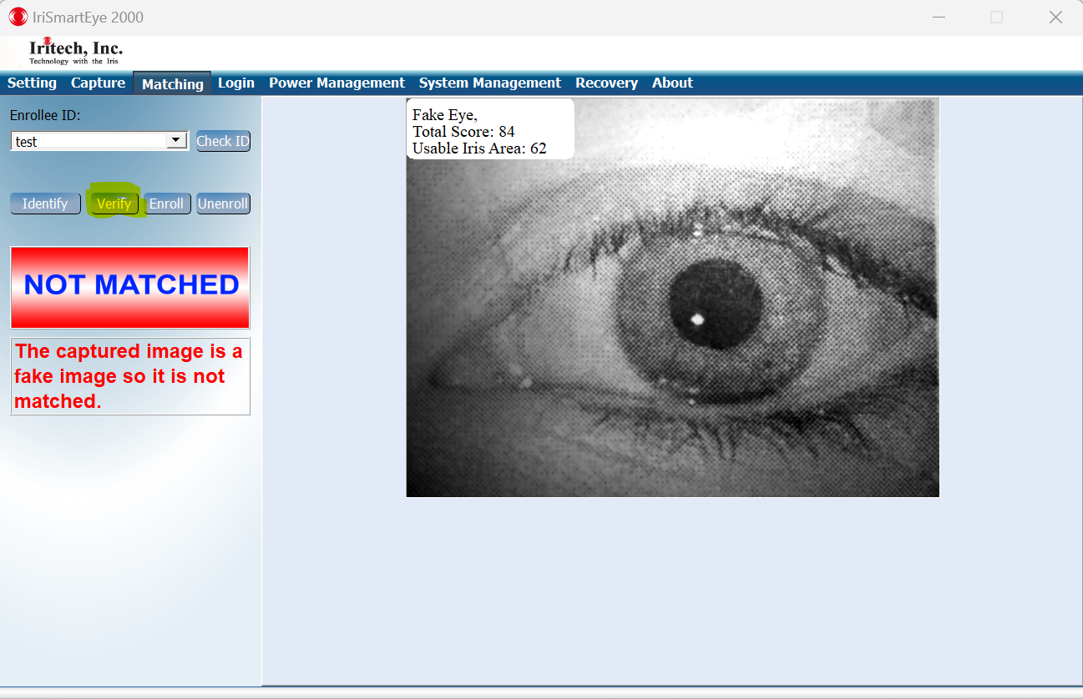

* + 1. **Identify**

1. Capture an iris image.
2. Click “Identify” to identify the enrollee from the enrollee list. Once located, the corresponding ID will be shown in the resulting message as in below.

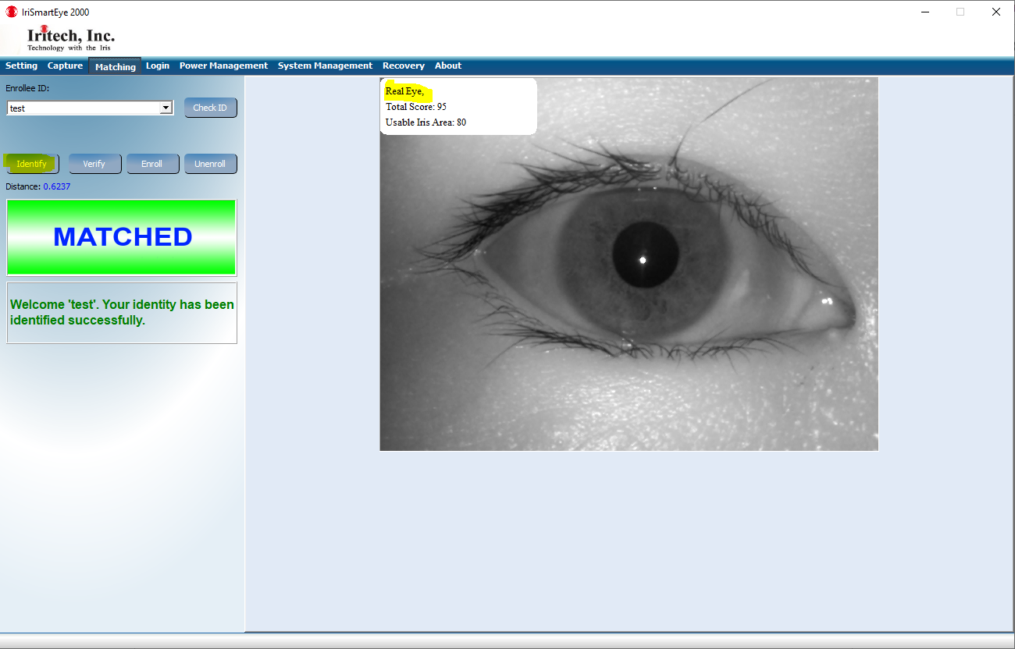

1. If the captured image is a fake image so it is not matched, the negative message is shown below.

